**Purpose**: Assignment for Oracle E- Business Suite Invoice & Payable

**Date:**6th Dec-2024

**Student**: Areba Hashmi

1. Query my invoice  
   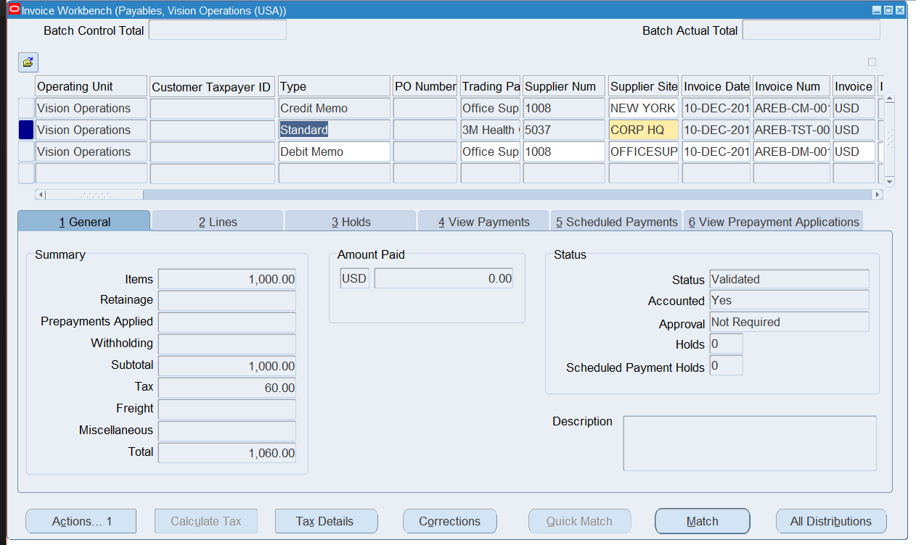
2. Actions > Payment

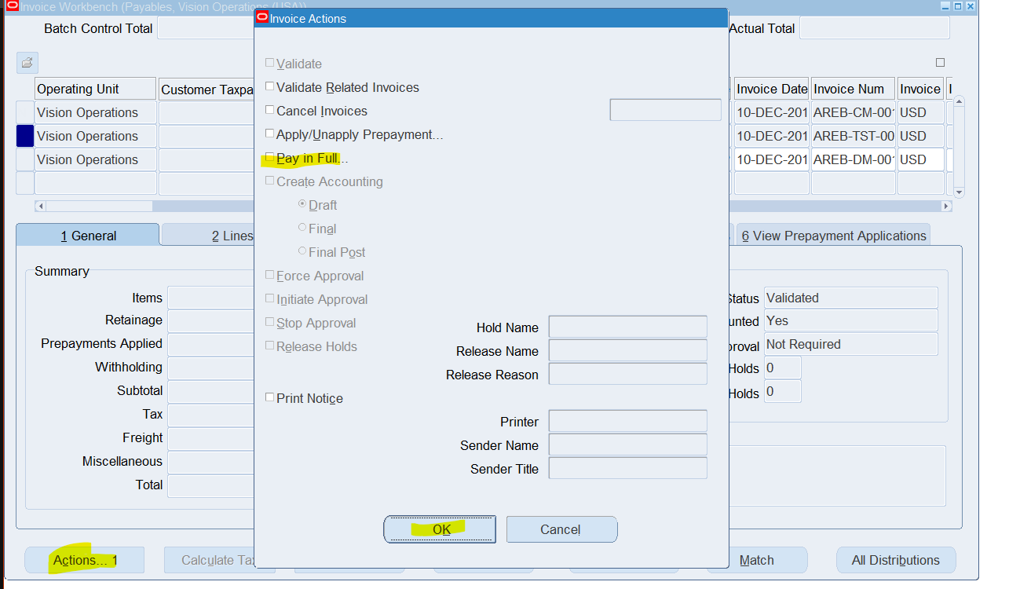

1. Open Payment workbench

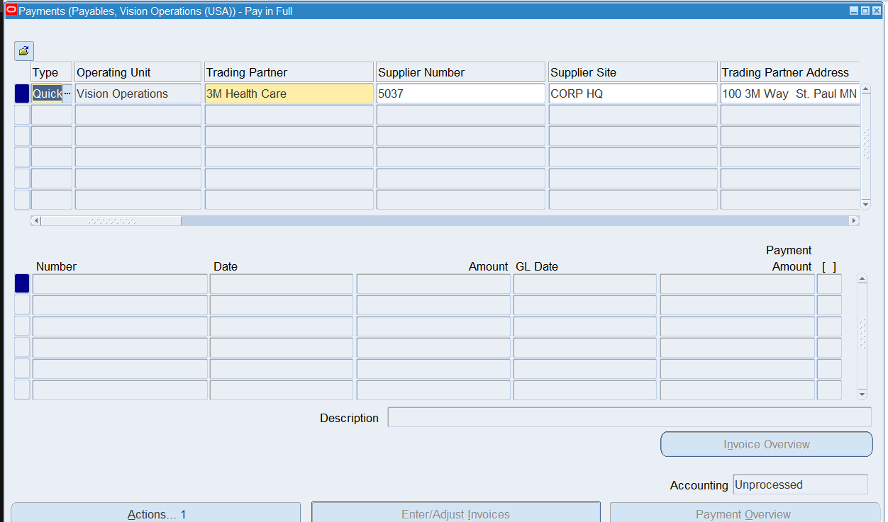

1. Fill mandatory fields & use date that is an open period

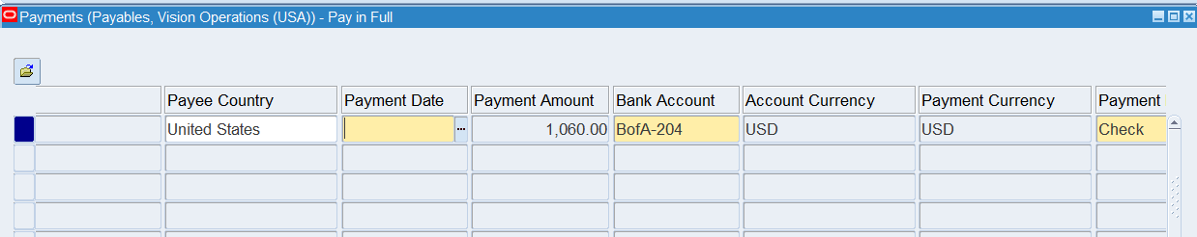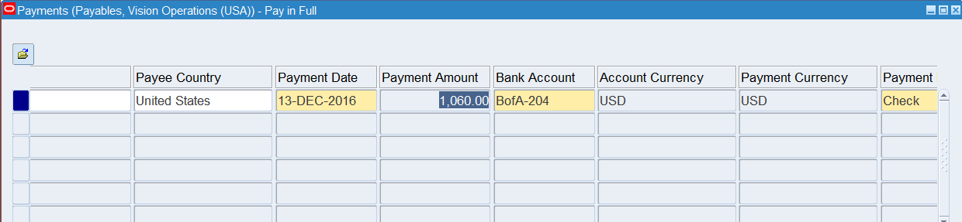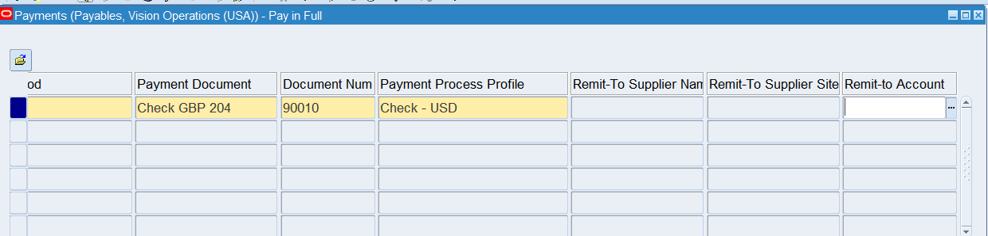

1. SAVE

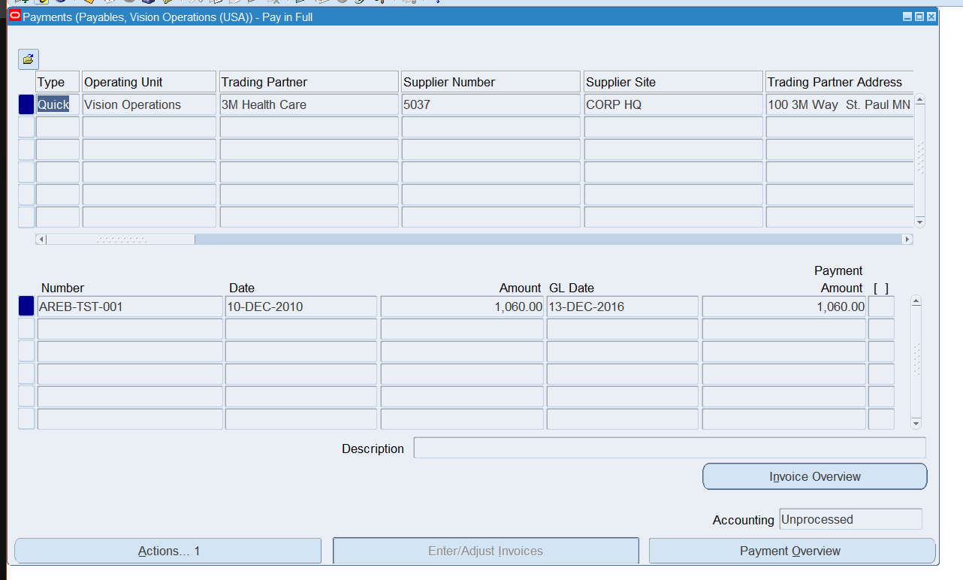

1. Actions > Create Accounting > Final Post

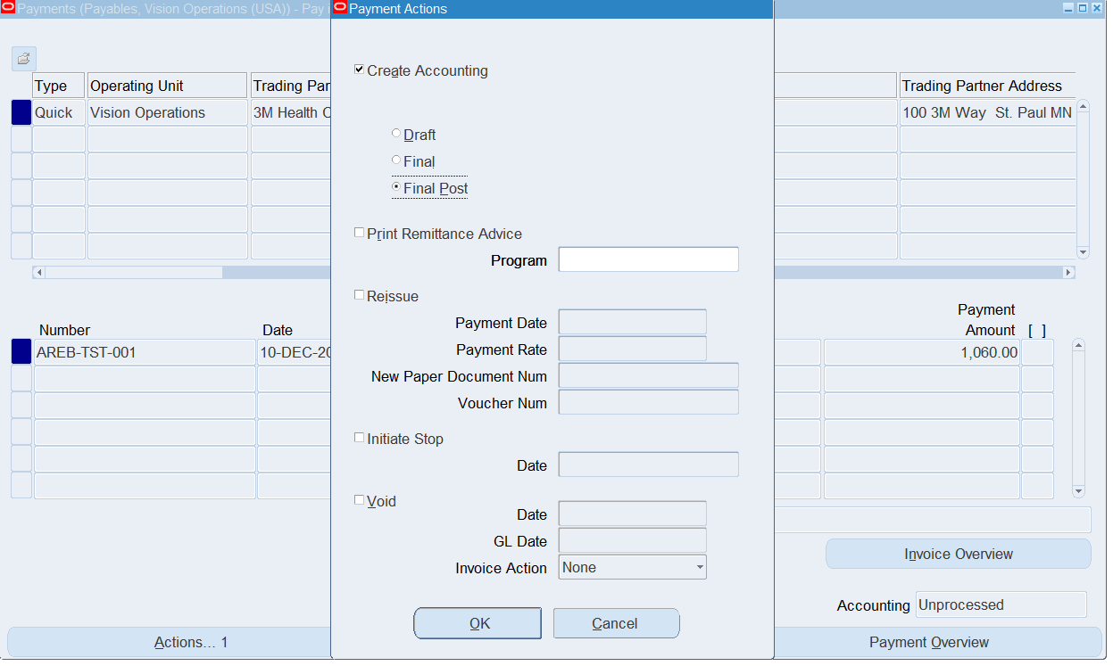

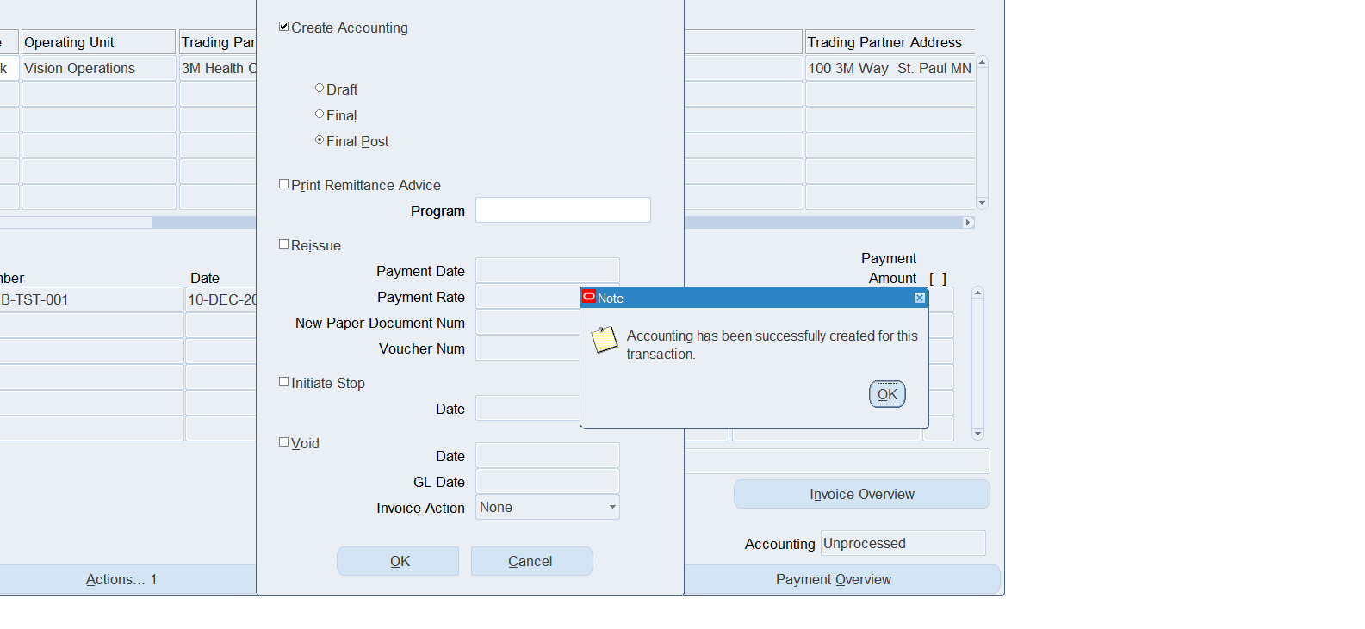

1. Return to the invoice and requery  
   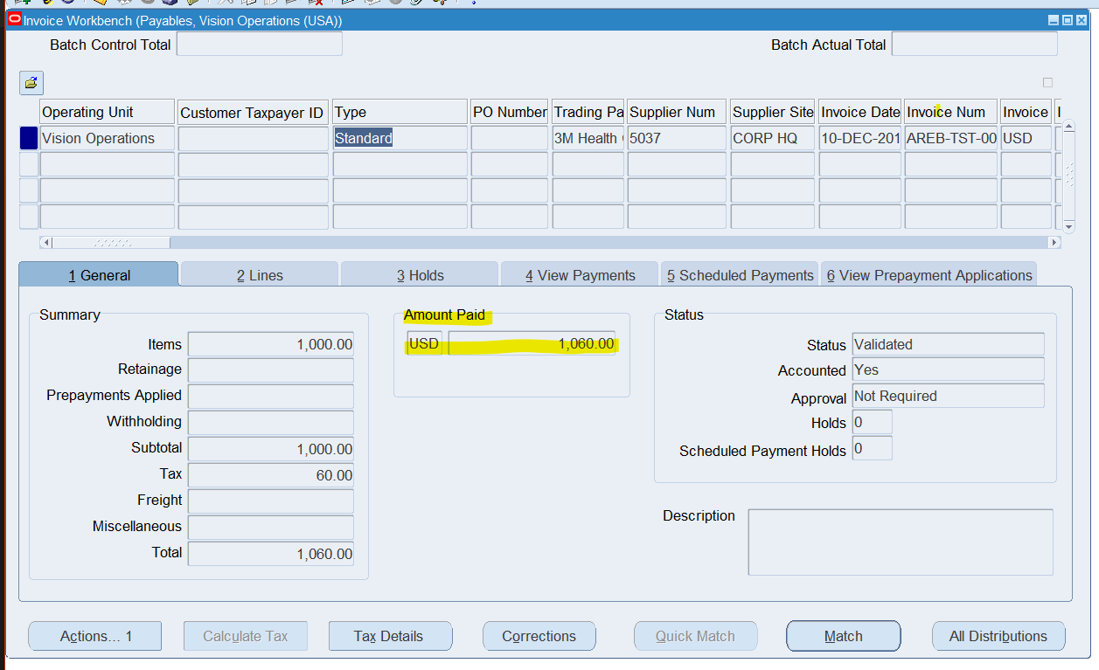
2. Return to Payment Overview & Query Document number > Actions

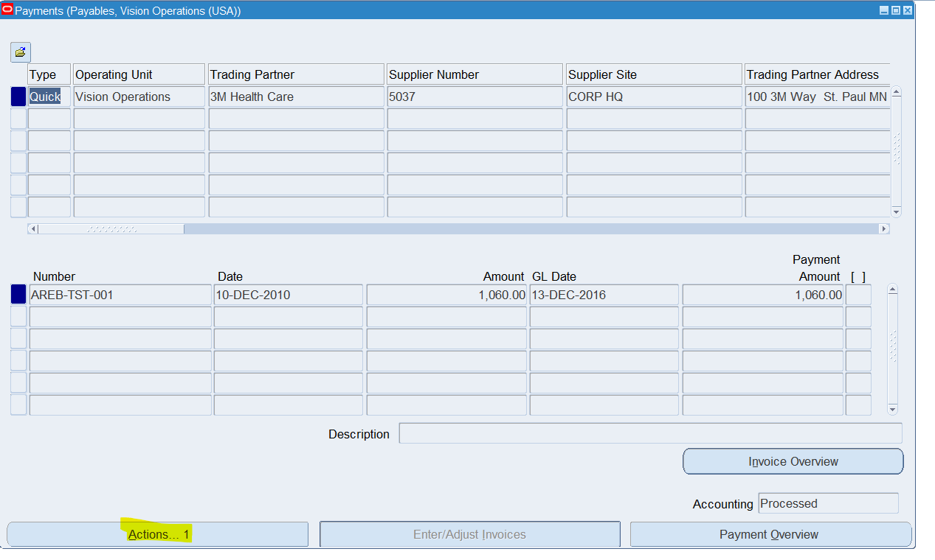

1. Print Remittance

